ComUUnicator
The Newsletter of the United Unitarian Universalist Congregation
Waukesha, Wisconsin
SEPTEMBER 2015
506 N. Washington Avenue  Waukesha, WI 53188  262-544-1050  www.UnitedUUC.org |  | 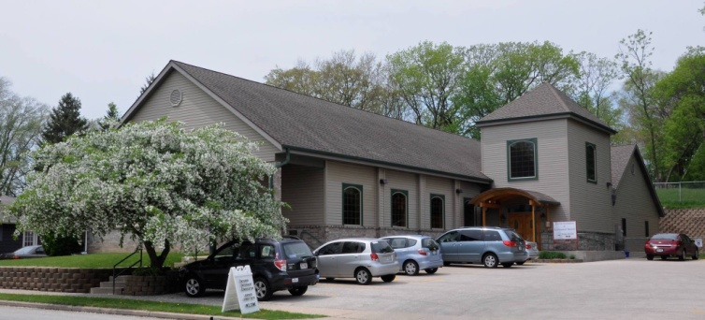 |  | OFFICE HOURS  Tuesday & Friday  9:00 am – 3:00 pm  MINISTER’S HOURS  Tuesday & Friday  10:00 am – 2:00 pm
United Worship Services
Every Sunday at 10:30 AM

August 2 , 2015 Annual Summer Picnic

August 9, 2015 “Grace and Gratitude” Guest Speaker: The Rev. Lori Hlaben

Our Universalist heritage held God’s grace to be abundant, poured out for every person without exception. Though many of us may have a different concept of God- or find such a concept unhelpful- many of us have cause to be grateful, a concept related to grace. Let’s explore the concepts together.

August 16, 2015 “Celebrating Life through Music”

Louis Armstrong said it best, “ What we play is life”. Today is our Music Director, Dan Collins’ last day with us at United. We want to celebrate life and what it means to all of us in a way he knows best, with music.

August 23, 2015 “ Animal Heroes” Guest Speaker: David Stokes

Who's the biggest, fastest, strongest among us? Using humor, live animals, animal artifacts, puppets and stories we will examine the animal heroes in our lives.

August 30,2015 To Be Announced Guest Speaker: Jennifer Thompson

The August 30th service information will be available as soon as possible and will be posted on our website and in our weekly announcements.

 | MINISTER’S LETTER |  | Pastor Schuyler Vogel  Minister@uniteduuc.org  262-544-1050

THE NEXT MINISTER’S LETTER WILL BE IN THE SEPTEMBER NEWSLETTER

FINAL TREASURER'S REPORT for 2014-15 Fiscal Year
Income |  | Final Figures for the |  | Amount Budgeted for the
 |  | Year 7/1/14 - 6/30/15 |  | Year 7/1/14- 6/30/15
 | Pledges | $51,135 |  | $52,728
 | Other Income | $49,658 |  | $40,037
 | Total Income | $100,793 |  | $92,765
Total Expenses |  | 86,195 |  | $88,006
Income - Expenses |  | $14,598 |  | $4,759
The surplus from 2014-15 is allocated as follows:
Carry over to help pay minister's salary: $6,000
Ministers' Benevolence Fund: $1,666
Emergency Fund: $4,000
Ordination Donations: $1,425 (Individual) + $1,000 (Church)

SEPTEMBER NEWSLETTER DEADLINE:
SEPTEMBER NEWSLETTER DEADLINE:
AUGUST 21, 2015
THANK YOU!
AUGUST 21,2015

New ways to support United!!
We're excited to announce three new ways you can support United by doing something you already do - shop online!
iGive
As of today, United is set up as a cause you can support when you shop using iGive.com.
Get started with iGive at: www.igive.com
If you join iGive in the next few days, get the iGive button for your web browser, and visit one of the listed websites, United gets $5 for each new user (no purchase necessary).

Goodshop/Goodsearch

United is also set up as a cause you can support when you shop or search the internet using Goodshop/Goodsearch.
Goodshop gives you the best coupons for thousands of stores like Target, Apple, Amazon, Petco and more AND a percentage of what you spend on virtually every purchase is donated to United! Plus, with the Goodshop app for iPhone and iPad, you can shop, save, and give on the go.
Goodshop: http://www.goodshop.com

In addition, United will receive $.01 for every web search you do on Goodsearch. That can really add up! Goodsearch:http://www.goodsearch.com/

Amazon Smile

In the next few weeks, United will be added to the Amazon Smile program as well.
AmazonSmile is a simple and automatic way for you to support your favorite charitable organization every time you shop, at no cost to you. When you shop at smile.amazon.com, you’ll find the exact same low prices, vast selection and convenient shopping experience as Amazon.com, with the added bonus that Amazon will donate a portion of the purchase price to your favorite charitable organization.
We'll update you when United is up and running with Amazon.

In the coming weeks, we will be updating the United website to include links to iGive, Amazon Smile and Goodsearch/Goodshop, so you can easily access them from one place. Please send this email on to others who might like to support United as well.

POTLUCKS
Our Potluck season is just around the corner in the Fall. Updates will come as we get closer to that time!

BUDDHIST GROUP
The group continues to meet the first and third Wednesday of each month near our former church in Mukwonago, at Linden Grove. The address is 837 County Rd. NN, Mukwonago, WI 53149. Anyone who may be interested is welcome to join us at any time. Those with questions can contact Patti Kies.

SUNDAY GREETERS AND COFFEE HOSTS
Greeters | Coffee Hosts
8/2 Summer Picnic  8/9 Meg & Monica W  8/16 Stewart K & Paula P  8/23 John & Carol P  8/30 Evan W & Chad L | 8/2 Summer Picnic  8/9 Sara T & Faye F  7/19 Patti K & John H  Dave A & Kim J  8/30 Chet & Sally C

